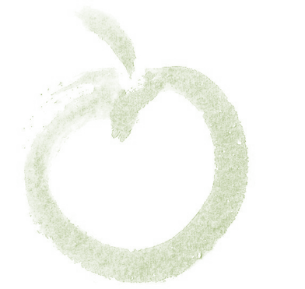
EVE’S GARDEN DESIGN
W: www.EvesGardenDesign.com E: Eve@EvesGardenDesign.com T: 530.448.0906
1299 Hobart Street, Chico, CA 95926
CA 3739

Weed supression using sheet composting
Sheet composting kills weeds by starving them of light. Dead plant material will break down into compost to enrich the soil. New weeds are reduced because it is difficult for them to anchor their roots in deep mulch. The sheeting and the mulch will break down over time, forming compost. Sheet mulching should be placed before new plants are installed if being used to kill lawn or weeds. It can be placed after plants are installed if other weed removal techniques such as solarizing have been completed first.
Materials:
- Newspaper or plain cardboard. Don’t use glossy colored pages as they may contain metal pigments.
- Water from a hose with a spray attachment.
- Compost in a 1-2” layer for gardens that will include edible plants or traditional landscape plants. Compost is not necessary for native plant gardens. Quantity calculation for mulch is: (Area in square feet) x .08 to .15 ÷ 27 = cubic yards of compost required.
- Wood chip mulch in a 4”-6” layer. ‘Walk-on’ bark, available at Sutherland’s, has longish strips of wood and barks that knit together to help it stay in place. You can also get shredded wood/bark from tree companies for much less cost; verify with the supplier that it is disease free. Quantity calculation for mulch is: (Area in square feet x .41 to .5) ÷ 27 = cubic yards of mulch required.
Process
- Scalp your lawn or weedy area with mower set at lowest setting. Remove grass/weed clippings.
- If the soil is compacted and/or dry, water thoroughly. To prevent runoff, you may have to apply water for a short period, wait for it to soak in, then repeat as needed.
- To reduce spillage of mulch onto adjacent paving, dig a narrow, shallow trench at the perimeter the area to be sheet. 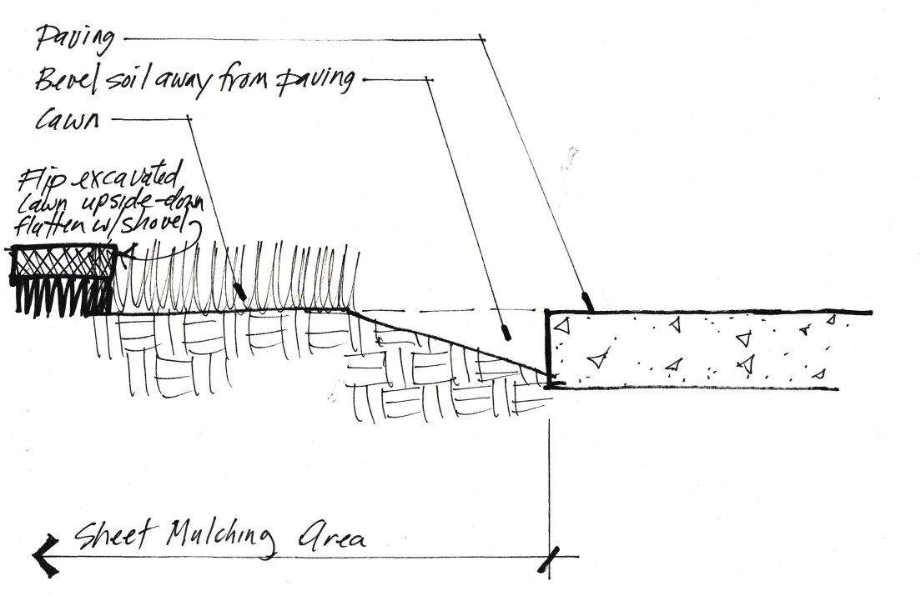
- For edible or traditional landscape gardens, place 1-2” depth of compost or worm castings over entire area. Omit this step for native plant gardens.
- On a windless day, place newspaper (about 5-8 sheets thickness) or cardboard over grass to be killed, overlapping like shingles. Make sure there or no gaps or holes. Lightly sprinkle newspaper with water as you go to prevent it from blowing away. Once wet, the paper will easily tear; be careful when walking on it. If it tears, place additional newspaper over the hole.
- If you are laying the sheeting around existing plants, keep the paper a foot from the plant stem, further for plants that spread by underground stems.
- As you are laying the paper, place wood mulch over the top of the paper to a 4”-6” depth. Place the mulch as you lay the paper so you don’t have to walk on/tear the wet paper. If you are placing the mulch when the plants are already in the ground, keep the mulch a foot from the plant stem.
- To plant after the sheet mulching is installed, push back the mulch and cut away newspaper in a circle wide enough to dig your hole. Dig the planting hole 2x the width and 1x the depth of the plant root ball. Loosen coiled roots and place the plant in the soil so that the top of the root ball is slightly above the adjacent soil. Back fill with soil from hole, forming a slight rim at the edge of the planting hole. Replace mulch but keep it from contacting the plant stems.
Resources.
Paper:
Chico New and Review
353 E. 2nd Street, Chico
530 894 2300
They often have a dumpster full of newspaper available for free; call first. Each edition of the N&R makes 2 shingles.
Wood chips and tree care:
Jeff Hauer, Branching Out Tree Care
530 354 4285
He will bring wood chips leftover from his operations to your yard for a small fee, upon availability.

